**HybridHive**

**Capstone Project- GrowthSchool**

Product Overview

**August 11, 2023**

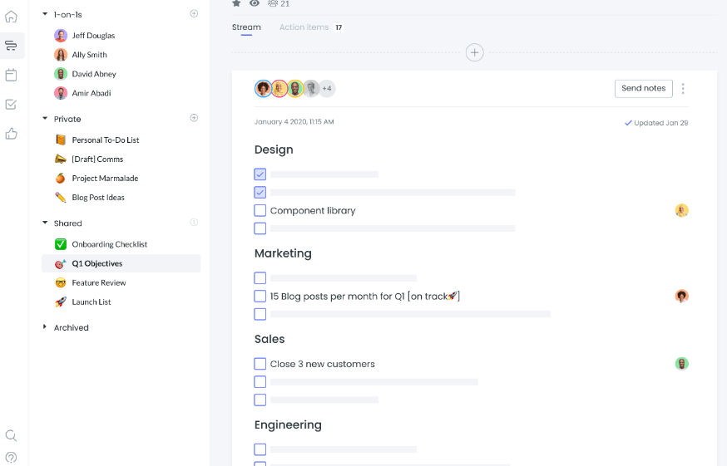

Are you part of a dynamic team that's a mix of remote and in-office members? Say hello to the Hybrid Team Productivity Tool – your secret weapon for seamless collaboration and enhanced productivity! Picture this: effortlessly chatting in real-time with your colleagues, managing tasks without missing a beat, and co-editing documents like you're all in the same room. It's like having a magic wand that brings everyone together, no matter where they work.

With smart features that help you work smarter, not harder, this tool is your go-to sidekick for making teamwork feel like second nature. From team leads to developers, we've got you covered. Unite your team, supercharge your productivity, and conquer projects with the Hybrid Team Productivity Tool – because your success is our mission!

## 

## 

## Unlock a New Era of Teamwork with Hybrid Team Productivity Tool!

Elevate your team's collaboration game with the Hybrid Team Productivity Tool – the ultimate solution for boosting synergy and productivity in remote and hybrid work environments. No more feeling disconnected or missing out on important updates. Stay in the loop, manage tasks effortlessly, and turn ideas into reality with just a few clicks. Experience the power of unified teamwork, whether you're at your desk or on the go. Your path to success starts here!

### Discover More:

Ready to embark on a journey of seamless teamwork and enhanced productivity? Dive into the details of the Hybrid Team Productivity Tool and see how it can transform the way your team works. Click the link below to explore the features, benefits, and how you can bring this game-changer to your team.

# Links to the Document

| **NAME** | **LINK** | **DATE OF SUBMISSION** |
| --- | --- | --- |
| Product Strategy- | [PRODUCT STRATEGY_ HybridHive Productivity Tool.pptx](https://docs.google.com/presentation/d/1aTslg8rMecRfAzRBGq30-dFMs4wmN3SF/edit?usp=sharing&ouid=101603461842536472810&rtpof=true&sd=true) | 11th August, 2023 |
| Product Requirement Documents (PRD) | [Capstone Project: PRD For HybridHive](https://docs.google.com/document/d/15IjmDuStOywwr9wc_RPUY--D-TZfg0NBPfMEdPERzpE/edit?usp=sharing) | 11th August, 2023 |
| Glide link | <https://hybridhive.glide.page> | 18th August, 2023 |
| Landing Page | <https://cheerful-kimchi-755991.framer.app/> | 18th August, 2023 |
| Figma website Presentation | [Presentation of Figma Designs.pdf](https://drive.google.com/file/d/1f4Uueue9KRbp3M_HJXtj9rYIBkQ97N7J/view?usp=sharing) | 18th August, 2023 |